
October 31, 2021
Prepared by Stefan Teeuwen, Florin Pană,
Robbe Vrijenhoek and Aleksandar Dobrev
LoRa security
Project plan
Fontys University of Applied Sciences

Table of Contents
Introduction 3
Research questions 4
Research approach 4
Way of Working 4
Task division 5
Planning 5
Sources 6

Introduction
The project plan will act as a guiding thread for the group during the project execution.
The project plan contains the tasks, the planning of the tasks, and other standard information about the project, to determine and help each step we take during the project execution, we can use this document as our fallback.
The project’s goal is to secure LoRa devices by building a system to monitor their outputted data. A LoRa device is a small device connected to or implemented in an IoT device. The LoRa device will then use the LoRa protocol instead of the internet to send the IoT device’s data to a central server. The LoRa protocol will send out radio signals on lower frequencies into the local area, these signals will be picked up by LoRa gateways in the area which will handle and send the data to a central server.
The challenge for this project is to get a good understanding of the way LoRa works to then invent a secure and efficient technique to monitor the LoRa protocol.

Research questions
We’ve come up with the following research questions to help us get more inclusive information, helping us learn more about LoRa.
Main research question:
What is the most efficient way to securely monitor LoRa devices?
Research sub-questions, to help us achieve our main goal:
- What is a LoRa device?
- How does a LoRa device work?
- How does the LoRa protocol work?
- What are existing methods to monitor LoRa devices?
- What are efficient methods to monitor LoRa devices?
- What are secure methods to monitor LoRa devices?

Research approach
For this research our research approach will differ per sub question; for the background information and context about the way LoRa works, we will use qualitative research methods. We require qualitative research to understand LoRa and start the project with rich knowledge about the way LoRa works, we just need the most detailed and inclusive information about LoRa which will be applicable in practice with our LoRa devices. For the following sub questions, we need to invent a way to monitor LoRa devices. We will first look for methods others have used to successfully monitor LoRa devices. Out of the obtained methods we will select the most secure and the most efficient method. To increase our chances of finding the best methods applicable, we will look for higher quantity of methods rather than a couple of qualitative methods that work well but might not all be applicable.

Way of Working
SCRUM methodology
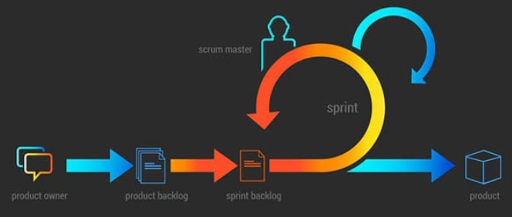
The team will work using the scrum methodology in 4 weekly sprints. We will organize several group meetings to work together and discuss what comes next in terms of deliverables. We are meeting the product owner (the teacher) every Thursday morning to discuss our progress, ask questions, and receive feedback.

Task division

- Literature study (initial research on what LoRa is and how it works).
- Florin and Robbe
- Available product analysis (research to find solution for our specific versions and devices).
- Florin and Robbe
- Obtaining and installing the hardware (LoRa devices).
- Aleksander and Stefan
- Code modification.
- Stefan, Robbe and Florin
- Creating the gateway.
- Aleksander and Stefan

Planning

The team will divide the work on 4 weekly sprints. After careful planning and consideration, the team decided to try and finish work in the first 3 sprints.
- Week 1: Research and first steps in the implementation
In week 1, the team needs to get acquainted with the LoRa concepts and find ways to do the given exercise. We decided to reserve one entire sprint for this, given that none of the team members have any experience with LoRa devices. There are two main goals in the research phase. The first is understanding the way LoRa devices and LoRaWAN work, by looking online for information. The second goal is to find code online that can further help us understand how to program LoRa devices.
- Week 2: Documentation, continuing the implementation
In week 2, after a first sprint focused on research alone, the team starts fully applying the scrum methodology and creates a project plan, while also documenting what is being discussed during the scrum meetings and the product owner meetings. The first implementation steps started in sprint 1, once some useful code has been found, and during this sprint the team will focus on changing that code to suit the project’s needs.
- Week 3: Finishing the implementation, applying the final touches
under favourable circumstances, the team will finish working on the project in 3 sprints. The code that the team has extended during the second sprint will reach its finishing stage. The documentation will also be complete, with a possible new addition, in the form of a project report.
- Week 4: Extra time in case of unforeseen circumstances
Officially the last week of the project, the team has decided to use it only in case of emergency. Careful planning, teamwork, and professionalism will play a major role in achieving this. However, if an unexpected issue will come up, which will delay our progress, it is good to have a safety net and sprint 4 fulfills this role.

